**PSG COLLEGE OF TECHNOLOGY**

**DEPARTMENT OF COMPUTER APPLICATIONS**

**23MX26 - Java Programming Laboratory**

**Hands-on Worksheet 5**

1. You would like to give away an awesome prize to one lucky person in the class that is selected randomly.

* Write a program that lets the user type in names. Each name that is entered should be stored in an ArrayList of type String. When the word "quit" is entered then the program should stop inputting names.
* Print a list of all contestants using a “for each” loop to display the contents of your ArrayList
* Then your program should generate a random number that could be any entry in the ArrayList and print out the name of the lucky winner.
* Remove any names that are duplicate – Hint: there are multiple ways to do this, you might consider using a 2nd ArrayList, nested loops, and/or a HashSet (which we haven’t covered in detail, but has a constructor that accepts ArrayLists).
* print the contents again to verify no duplicates exist

2. 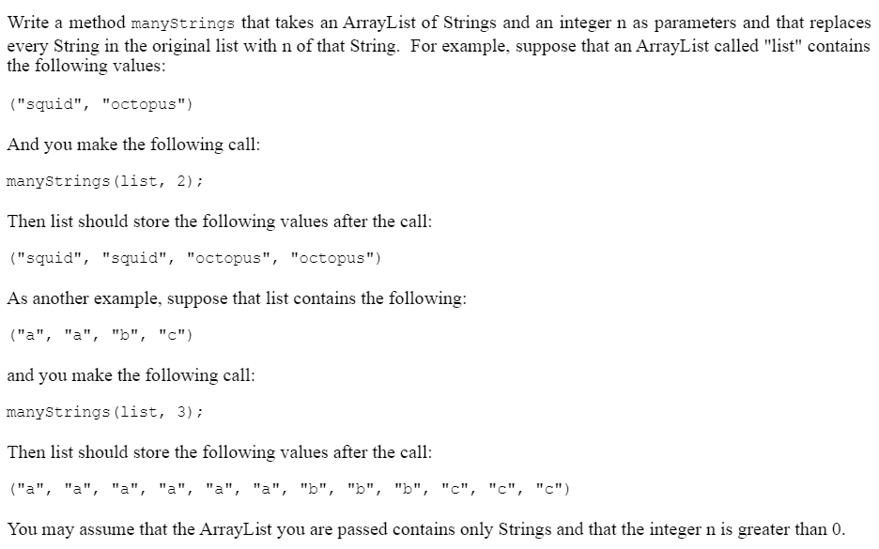

3. Write a program that simulates shopping. The program should have a loop that continues as long as the user wants to shop. Each time through the loop read in the name, price, and quantity of the item the user wants to add to the cart. After adding an item to the cart, the cart contents should be printed. After the loop print a "Please pay ..." message with the total price of the items in the cart.